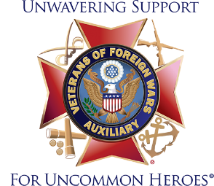
My dear Brothers and Sisters,
It is my honor to announce to you my intention to run for the National #8 Council seat.
I have been a member of this great organization for over 20 years, and I understand how National works. This seat on the National Council represents Alabama and Georgia’s best interest. My experience and knowledge of the VFW Auxiliary bylaws and programs will be a great asset to our States.
I joined the Auxiliary under the eligibility of my father who was a three-war veteran. My goal in this organization is to carry on the work of helping our veterans and the community. Our children need now more than ever to love our country and be taught patriotism. We are sometimes the only ones visiting our veterans in the nursing homes and making sure they have what they need.
These are the things I believe in and will carry to National with me if elected. I have had the honor of holding many positions in the Auxiliary, District and State that are listed below.
Our Department has been losing members over the last few years but today we are gaining members! With the leadership of our President, Line Officers, Chairman and members we are coming back!
I hope to be a part of the Team for many more years and with Gods blessings I will be able to.
Positions held:
- Department President
- District President
- Auxiliary President
- Department Chief of Staff for 3 Presidents
- Department Secretary - Current
- Many Department Chairmanships and won plates at National.
- The VAVS rep for the Montgomery VA for many years.
I hope this gives you some information about me that will help in your decision to consider me for the position of Council member #8, to represent you at the National level.
Thank you for what you do.
Sincerely,
Kathy Rowe

