Join us to celebrate
Madame President Stephanie’s
Homecoming!
Friday, June 13, 2025
Time: Immediately following the afternoon session
(at Department June Convention Embassy Suites Mongomery)

This “Sweet land of LIBERTEA” gathering is hosted by District 3 and will feature light tea-party fair, including mini tea sandwiches, tea cakes, fruit, nuts, and of course TEA.
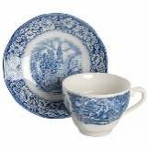
So, dawn your chapeau and raise your pinky for President Stephanie, and let’s celebrate together!
Protocol: Gifts are gratefully accepted but not expected. Typically, gifts are given by District, but also from Auxiliaries or individuals would not be unusual.

